# TITLE PAGE

**DESIGN AND IMPLEMENTATION OF DEPARTMENTAL FEES PAYMENT SYSTEM (CASE STUDY OF COMPUTER SCIENCE DEPARTMENT)**

**BY**

**AJAVER TIMOTHY JEREMIAH**

**ST/CS/ND/21/114**

**DEPARTMENT OF COMPUTER SCIENCE,**

**SCHOOL OF SCIENCE AND TECHNOLOGY,**

**FEDERAL POLYTECHNIC, MUBI, ADAMAWA STATE.**

**IN PARTIAL FULFILLMENT OF THE REQUIREMENT FOR THE AWARD OF NATIONAL DIPLOMA (ND) IN COMPUTER SCIENCE.**

**SEPTEMBER, 2023**

# DECLARATION

I hereby declare that the work in this project titled **“Design and Implementation of Departmental Fees Payment System (Case Study of Computer Science Department)”** was performed by me under the supervision of Mr. Musa Simon. The information derived from literatures has been duly acknowledged in the text and a list of references provided. The work embodied in this project is original and had not been submitted in part or in full for any other diploma or certificate of this or any other institution.

AJAVER TIMOTHY ________________ _______________

(ST/CS/ND/21/114) Signature Date

# CERTIFICATION

This project titled **“Design and Implementation of Departmental Fees Payment System (Case Study of Computer Science Department)”** meets the regulations governing the award of National Diploma (ND) in Computer Science, Federal Polytechnic Mubi, Adamawa State

Mr. Musa Simon __________________

(Project Supervisor) Sign/Date

Mr. Mustapha Kassim __________________

(Head of Department) Sign/Date

Mal. Abdulrahman Saidu _________________

(External Examiner) Sign/Date

# DEDICATION

This project is dedicated to my beloved parents for their advice, encouragement and financial support towards my academic pursuit.

# ACKNOWLEDGEMENTS

I want to acknowledge Almighty God for his infinite mercy and protection throughout my academic activities. And for the understanding in achieving our academic success.

I also recognize my Supervisor Mr. Musa Simon, who took time, despite her busy schedule to directed and guided me throughout this research work.

I also acknowledge the Head of Department Computer Science Mr. Mustapha Kassim for his moral encouragement throughout my period of study. I also acknowledge all Staff of Computer Science Department for their support and encouragement and the knowledge they’ve impacted on me throughout our studies.

I also want to appreciate our parents for their love and care and for giving me the opportunity to be trained and achieve our dreams.

Finally, I appreciate the efforts of my Uncles and aunties, for their encouragement and support throughout the course of our study and also our friends and relatives, course mates and all well-wishers. I love you all, may the Almighty God bless you abundantly, Amen.

# TABLE OF CONTENTS

TITLE PAGE i

DECLARATION ii

CERTIFICATION iii

DEDICATION iv

ACKNOWLEDGEMENTS v

TABLE OF CONTENTS vi

LIST OF FIGURES viii

LIST OF TABLES ix

ABSTRACT x

CHAPTER ONE 1

INTRODUCTION 1

1.1 Background to the Study 1

1.2 Problem Statement 3

1.3 Aim and Objectives 3

1.4 Significance of the Study 3

1.5 Scope of the Study 4

1.6 Definition of Some Operation Terms 4

CHAPTER TWO 5

LITERATURE REVIEW 5

2.1 Introduction 5

2.2 Departmental Fees Payment System in Educational Institutions 5

2.3 Automation and Efficiency 6

2.4 Information Management System 7

2.4.1 Importance of Information Management Systems 7

2.5 Database Management System 7

2.6 Summary of Literature Review 8

CHAPTER THREE 9

SYSTEM ANALYSIS AND DESIGN 9

3.1 Introduction 9

3.2 Disadvantages of the existing system 9

3.3 Advantages of the proposed system 9

3.4 The Proposed Method 10

3.5 Method of Data Collection 11

3.6 System Design 11

3.6.1 Algorithm Diagram 12

Table 3.1: Transactions Table 13

3.7 System Requirements Specification 18

3.7.3 Personnel Requirements 18

CHAPTER FOUR 19

RESULTS AND DISCUSSION 19

4.1 Introduction 19

4.2 Results 19

4.3 Discussion 22

4.4 User manual 23

CHAPTER FIVE 24

SUMMARY, CONCLUSION AND RECOMMENDATIONS 24

5.1 Summary 24

5.2 Conclusion 24

5.3 Recommendations 24

5.4 Contribution to Knowledge 24

5.5 Area for further work 25

REFERENCES 26

# LIST OF FIGURES

Figure 3.1: Waterfall Model - - - - - - - - 11

Figure 3.2: Use case diagram- - - - - - - - 12

Figure 3.3: System Architecture- - - - - - - - 13

Figure 3.4: Database Entity Relationship Diagram- - - - - - 15

Figure 3.5: Login interface- - - - - - - - - 15

Figure 3.6: Sign Up Form- - - - - - - - - 16

Figure 3.7: Payment interface- - - - - - - - 16

Figure 3.8: Make Payment Interface- - - - - - - - 17

Figure 3.9: Transactions interface- - - - - - - - 17

Figure 3.10: Payment confirmation interface- - - - - - 18

Figure 4.2.1: Welcome Interface- - - - - - - - 19

Figure 4.2.2: Login page interface- - - - - - - - 19

Figure 4.2.3: Registration Interface- - - - - - - - 20

Figure 4.2.4: Make Payment Interface- - - - - - - 20

Figure 4.2.5: New Payment Interface- - - - - - - 21

Figure 4.2.6: Payment Receipt- - - - - - - - 21

# LIST OF TABLES

Table 3.1: Transactions - - - - - - - - 16

Table 3.2: Fees - - - - - - - - - 17

Table 3.3: Students - - - - - - - - - 17

Table 3.4: Users - - - - - - - - - 17

# ****ABSTRACT****

*The "Design and Implementation of Departmental Fees Payment System (Case Study of Computer Science Department)" represents a pivotal milestone in the realm of academic administration and financial management within higher education. This innovative system is engineered to simplify and automate the complex process of fees payment and financial transactions within the Computer Science Department, offering enhanced convenience, accuracy, and transparency. The system provides an intuitive and user-friendly platform that benefits both students and departmental staff, facilitating seamless payment processing, fee tracking, and financial reporting. Through successful implementation, the Computer Science Department has established a blueprint for harnessing technology to streamline financial operations, reduce manual workloads, and bolster financial accountability. This abstract serves as a glimpse into the transformative power of the "Departmental Fees Payment System," showcasing how technology can revolutionize financial management within academic institutions, ultimately fostering an environment conducive to academic excellence and administrative efficiency.*

# CHAPTER ONE

# INTRODUCTION

## 1.1 Background to the Study

Institutions of higher learning, such as universities and colleges, handle numerous administrative tasks on a regular basis, one of which is the collection of departmental fees from students. Departmental fees encompass various charges related to academic activities, extracurricular programs, and other services offered by a specific department within an academic institution. Efficient and accurate management of these fees is essential for the smooth functioning of the department and ensuring the timely provision of essential resources and services. In recent years, the higher education landscape has witnessed significant changes with the rapid advancement of technology. Many institutions have recognized the need to embrace digital solutions to address the limitations and inefficiencies of traditional manual systems. Among the emerging technological solutions, web-based applications and online payment systems have shown great potential in transforming fee payment processes (Turner & Gonzalez, 2022).

The Department of Computer Science, Federal Polytechnic, Mubi is no exception. With a growing number of students and an increasing array of activities and services, the traditional manual fee payment system has become cumbersome, error-prone, and time-consuming. To address these challenges, there is a need to develop a modern and robust Departmental Fees Payment System tailored to the specific requirements and functionalities of the Computer Science department. In today's rapidly evolving educational landscape, institutions face increasing demands for efficient financial management systems that cater to the diverse needs of their students and staff. One critical aspect of this management is the collection and handling of departmental fees. Departmental fees encompass various charges specific to individual academic departments, such as course materials, laboratory usage, and field trips. As academic institutions continue to grow in size and complexity, traditional manual fee collection methods prove to be inadequate, leading to inefficiencies, errors, and a lack of transparency (Patel & Johnson, 2023).

To address these challenges and embrace the benefits of digitalization, educational institutions are turning towards innovative technological solutions, such as Departmental Fees Payment Systems (DFPS). A DFPS streamlines the entire fee payment process by automating fee calculations, enabling online payments, and providing real-time access to fee-related information. This allows students, faculty, and administrative staff to manage fees seamlessly, resulting in enhanced financial transparency and improved overall institutional efficiency. The emergence of advanced technologies, such as cloud computing, secure payment gateways, and data encryption, has opened up new possibilities for developing comprehensive DFPS solutions tailored to the specific needs of educational institutions. These solutions not only cater to the demands of a modern-day academic setting but also ensure the security and privacy of sensitive financial information.

Recent studies emphasized the relevance and significance of implementing a Departmental Fees Payment System in the context of modern educational institutions. By harnessing technological advancements and addressing specific challenges in fee management, DFPS solutions can play a vital role in optimizing financial operations and enhancing the overall academic experience for all stakeholders involved.

Zhang and Chen (2022), in their study investigates the adoption of electronic payment systems in higher education and highlights the advantages of transitioning from traditional fee payment methods to digital solutions. The research emphasizes the need for user-friendly DFPS to accommodate various stakeholders and improve overall user experience. Brown and Martinez (2022), explore the challenges faced by educational institutions in implementing digital fee management systems. The study also identifies the opportunities presented by DFPS in terms of cost savings, error reduction, and enhanced financial reporting.

Wu and Lee (2023), in their study delved into the critical aspect of security in designing payment systems for universities. It emphasizes the importance of incorporating robust security measures to safeguard sensitive financial data and protect against potential cyber threats. Through surveys and interviews, this study gathers student perspectives on the adoption of payment systems in higher education. It identifies the factors that influence students' preferences for digital fee payment options and explores their overall satisfaction with existing DFPS. This research evaluates the impact of implementing payment systems on financial management practices within universities. It highlights the benefits of automation in fee collection, reducing administrative burden, and increasing financial transparency.

Irina Ioniță and Elena-Alexandra Gorgos, titled "Challenges and Solutions in Implementing Online Payment Systems for Universities," explores the benefits of online payment systems in universities and highlights the challenges that institutions may face during implementation (Ioniță & Gorgos, 2016).

Another research paper by Teo Cher Ming and Ahmad Sobri Hashim, titled "Adoption of Online Fee Payment by Public Higher Education Institutions in Nigeria," investigates the adoption and usage of online fee payment systems in public universities in Nigeria. The study sheds light on the factors influencing the successful implementation of such systems and highlights their impact on the efficiency of financial processes in educational institutions (Ming & Hashim, 2018).

## 1.2 Problem Statement

The current manual fee payment system in the Department of Computer Science is plagued by various issues, such as; Limited Accessibility: Students face difficulties in accessing information about their fees, payment deadlines, and outstanding balances. This lack of accessibility leads to delays and missed payments.

Human Errors: Manual data entry and calculation increase the chances of human errors in fee processing, causing discrepancies and inconvenience to both students and department staff.

Time-Consuming: The manual system demands a significant amount of time and effort from administrative staff, leading to delays in processing fees and other essential administrative tasks.

Inefficiency in Record-Keeping: Managing and storing physical fee-related documents can be cumbersome and prone to damage or misplacement. With the growing reliance on digital transactions, the absence of online payment methods limits convenience for students and hinders the department's ability to adapt to modern payment trends.

## 1.3 Aim and Objectives

The aim of this project is to design and implement a departmental fees payment system for computer science, Federal Polytechnic, Mubi. The specific objectives are:

1. To create a system for the payment of departmental, NACOSS and Practical Manual fees.
2. To implement an efficient and secure online platform that allows students to access fee-related information, make payments, and print receipts electronically.
3. To streamline the fee collection process, reducing the administrative burden on the department staff and minimizing the occurrence of errors.
4. To provide accurate and up-to-date financial reports to department administrators for better decision-making and financial planning.

## 1.4 Significance of the Study

The successful implementation of the Departmental Fees Payment System will yield several significant benefits; The system will streamline fee processing, reducing the time and effort required for administrative tasks and enhancing overall efficiency. Students will have easy access to their fee-related information, ensuring transparency in transactions and promoting accountability. By automating the fee processing, the system will minimize human errors, leading to more accurate financial records. The shift to digital payment methods will reduce paperwork and associated costs, making the fee collection process more cost-effective. The user-friendly interface and online payment options will enhance the overall experience for students, making fee transactions convenient and hassle-free.

## 1.5 Scope of the Study

This project focuses solely on the design and implementation of the Departmental Fees Payment System for the Computer Science department. It includes the development of a web-based application accessible to both students and administrative staff. The system will facilitate various fee-related operations, including fee inquiry, payment submission, receipt generation, and record-keeping.

However, this project does not cover the integration of the Fees Payment System with the institution's central finance system. It also does not delve into the broader financial management of the entire Federal Polytechnic, Mubi

## 1.6 Definition of Some Operation Terms

**Automation:** Automation in the context of a Departmental Fees Payment System involves the use of software and technology to perform fee-related tasks and processes that would otherwise be done manually (Wu & Brown, 2022).

**Database**: A database refers to an organized collection of structured data that is stored, managed, and accessed using specific software and methodologies (Lee & Koo, 2021).

**Online**: Online refers to the state or mode of being connected to the internet or the use of computer networks to access and interact with information, services, or resources (Chen & Chen, 2021).

**Payment**: It involves the settlement of financial transactions between parties and can be conducted using various methods such as cash, checks, credit/debit cards, and electronic transfers (Sutanto et al., 2020).

**Portal**: A portal refers to a web-based platform or gateway that provides access to various resources, information, and services (Li et al., 2020).

**Security Measures:** Security measures refer to a set of protocols, practices, and technologies implemented within the Departmental Fees Payment System to protect sensitive financial data, prevent unauthorized access, and safeguard against potential cyber threats or breaches (Anderson & Patel, 2022).

**System**: A system refers to a collection of interconnected components, processes, or elements that work together to achieve a specific purpose or objective (Huang, 2021).

# CHAPTER TWO

# LITERATURE REVIEW

## 2.1 Introduction

This chapter presents a comprehensive review of the existing literature on Departmental Fees Payment Systems (DFPS) in educational institutions. The literature review aims to provide insights into the current state of research, best practices, challenges, and opportunities in implementing DFPS. Recent scholarly works are examined to understand the importance of digitalizing fee management and its impact on financial transparency, user experience, and institutional efficiency.

## 2.2 Departmental Fees Payment System in Educational Institutions

The importance of Departmental Fees Payment Systems (DFPS) in educational institutions cannot be overstated. As academic institutions continue to grow in size and complexity, manual fee collection processes prove to be inadequate in meeting the demands of students, faculty, and administrative staff. DFPS offers a range of benefits that contribute to improved financial management, operational efficiency, and overall student satisfaction.

Several studies have emphasized the growing importance of implementing DFPS in educational institutions to enhance financial management and improve overall operational efficiency. Smith (2021), highlights the role of DFPS in facilitating digital transformation in higher education, allowing institutions to embrace modern payment methods and streamline fee transactions. Additionally, Johnson and Martinez (2021), emphasize how DFPS contributes to financial transparency, enabling stakeholders to access real-time fee-related information, monitor financial health, and make informed decisions.

One of the primary advantages of Departmental Fees Payment Systems is error reduction in fee management. Brown and Smith (2022), examine the impact of payment systems on error reduction in educational institutions. The research highlights how automation and digitalization minimize mistakes in fee calculations, leading to increased financial accuracy and transparency. Departmental Fees Payment Systems plays a crucial role in enhancing financial transparency within educational institutions. By providing real-time access to fee-related information, students, faculty, and administrators can gain insights into their financial obligations, payment statuses, and outstanding dues. This level of transparency fosters trust among stakeholders and ensures that financial decisions are made based on accurate and up-to-date data (Smith, 2021).

Implementing DFPS streamlines the entire fee management process. Automation of fee calculations, invoice generation, and payment processing significantly reduces the administrative burden on staff, allowing them to focus on more strategic tasks. The system's ability to generate accurate fee statements and reminders ensures timely fee collection, contributing to improved institutional cash flow (Johnson & Martinez, 2021).

Departmental Fees Payment Systems offers a user-friendly interface that simplifies the fee payment process for students and staff. With intuitive navigation and easy access to fee-related information, students can view their payment history, breakdown of charges, and make payments conveniently. Faculty and administrative staff benefit from quick access to fee-related reports, allowing them to verify payment statuses and resolve queries efficiently. A positive user experience contributes to higher student satisfaction and increased adoption of the system (Turner & Gonzalez, 2022).

Manual fee management processes are prone to errors and discrepancies. DFPS significantly reduces the occurrence of errors by automating fee calculations and invoice generation. The system's accuracy ensures that students are charged the correct fees, eliminating disputes and reconciliation issues. As a result, DFPS contributes to financial accuracy and fosters a culture of trust and accountability within the institution (Brown & Smith, 2022).

The implementation of Departmental Fees Payment Systems leads to cost and time savings for educational institutions. Manual fee collection processes often require significant administrative efforts, including handling paperwork, managing cash, and reconciling payments. DFPS automates these tasks, reducing the need for manual intervention and saving both time and resources. The system's efficiency also minimizes the need for follow-ups and reduces the administrative workload, resulting in cost savings for the institution (Wu & Brown, 2022).

## 2.3 Automation and Efficiency

Automation is a key aspect of Departmental Fees Payment Systems that significantly impacts operational efficiency. Wu and Brown (2022), discuss the role of automation in educational financial management and how it reduces manual intervention, leading to faster and more accurate fee transactions. The study underscores how automation eliminates errors in fee calculations and accelerates payment processes, saving time for both students and administrative staff. With the increasing reliance on digital systems, security is a critical concern in the design of Departmental Fees Payment Systems. Anderson and Patel (2022), delve into the challenges and measures to ensure data security in payment systems for educational institutions. The research highlights the need for robust security protocols to protect sensitive financial data and safeguard against potential cyber threats or breaches.

User experience plays a vital role in the successful adoption of Departmental Fees Payment Systems. Turner and Gonzalez (2022), explore the significance of improving user experience in educational payment systems. The study emphasizes that a user-friendly interface, easy navigation, and efficient payment processes positively influence student satisfaction and encourage the adoption of Departmental Fees Payment Systems. The use of payment gateways is essential for enabling secure online fee transactions. Zhang and Chen (2022), explore the advancements in payment gateway technologies in educational institutions. The study emphasizes how modern payment gateways offer various payment options, ensuring a seamless and secure fee payment experience for students.

## 2.4 Information Management System

An information management system (IMS) is a comprehensive framework that encompasses the processes, technologies, and strategies used to collect, organize, store, retrieve, and analyze information within an organization. An information management system refers to the integrated set of processes, tools, and technologies that enable organizations to effectively manage their information assets. It includes various components such as data collection, storage, retrieval, analysis, and dissemination (Khumalo, 2020).

## 2.4.1 Importance of Information Management Systems

1. Decision Making and Strategic Planning IMS enables organizations to gather and analyze relevant data, providing valuable insights that support informed decision-making and strategic planning (Delen, 2021). By providing accurate and up-to-date information, IMS enhances the ability of managers to make informed decisions in a timely manner.
2. Improved Efficiency and Productivity Efficient information management improves operational efficiency and productivity. By centralizing information, eliminating duplication, and automating processes, IMS streamlines workflows, reduces manual effort, and enhances overall efficiency (Wang, Liu, & Lee, 2021).
3. Enhanced Collaboration and Knowledge Sharing IMS facilitates effective collaboration and knowledge sharing within organizations. It provides a centralized platform for employees to access and share information, fostering collaboration, and enabling knowledge transfer (Al-Khouri & Abu-Jarour, 2020).

## 2.5 Database Management System

Database Management Systems (DBMS) are essential tools for storing, organizing, managing, and retrieving data efficiently. DBMS provide a structured approach to store and retrieve data, ensuring data integrity, security, and scalability for organizations. Recent studies have highlighted the significance of DBMS in various domains. A research article by Ramakrishnan and Gehrke (2020), emphasized that DBMS are crucial for managing the increasing volumes of data generated in today's digital world. The study highlighted that DBMS enable organizations to handle diverse data types, ensure data consistency, and support complex data queries.

One of the key functions of DBMS is data storage and organization. DBMS provide a structured framework for storing data in tables, defining relationships between tables, and enforcing data integrity through constraints. These systems often employ relational models, such as the widely-used SQL (Structured Query Language), to manage data in a tabular format. A study by Elmasri and Navathe (2019), emphasized that DBMS enable efficient data storage, normalization, and indexing to optimize data retrieval performance. Moreover, DBMS offer tools for data retrieval and manipulation. These systems allow users to query the database using SQL or other query languages to retrieve specific data based on specified criteria. DBMS also support complex operations such as joining multiple tables, filtering data, and aggregating results. A research article by Rizvi et al. (2021) highlighted the role of DBMS in enabling efficient and accurate data retrieval, facilitating decision-making and analysis.

DBMS also provide mechanisms for data security and access control. These systems enable organizations to define user roles and permissions, ensuring that only authorized users can access and modify the data. DBMS also offer features such as data encryption, backup, and recovery to protect against data breaches and system failures. A study by Motahari-Nezhad et al. (2021) emphasized the importance of DBMS in ensuring data privacy, integrity, and availability, particularly in the context of sensitive and regulated data.

## 2.6 Summary of Literature Review

This literature review provides valuable insights into the significance of Departmental Fees Payment Systems in educational institutions. The studies discussed emphasize the importance of automation, security, user experience, and error reduction in optimizing financial management. By leveraging cloud computing and modern payment gateway technologies, educational institutions can enhance their fee management systems, improve financial transparency, and provide students with a seamless fee payment experience. However, to successfully implement DFPS, institutions must address challenges and capitalize on opportunities to ensure a smooth and efficient transition towards digital fee management.

# CHAPTER THREE

# SYSTEM ANALYSIS AND DESIGN

## 3.1 Introduction

This chapter contains the system design and analysis of the proposed system, the disadvantages of the existing system in Departmental Fee Payment System, Federal Polytechnic, Mubi, the advantages of the proposed system over the existing system, the requirements (Hardware and Software), the design and the system architecture.

## 3.2 Disadvantages of the existing system

The following are the disadvantages of the present system, outlined as follows:

1. The existing system likely involves a lot of manual work, such as filling out paper forms, handling cash or cheques, and maintaining physical records.
2. Parents and guardians may have to visit the school premises physically to make fee payments.
3. The existing system might only accept a few payment methods, such as cash or cheques.
4. The manual processing of fees can be time-consuming for school administrators and staff, diverting their focus from other critical tasks.
5. The existing system may not be integrated with other school management systems, leading to duplication of efforts and data discrepancies.

## 3.3 Advantages of the proposed system

The proposed Departmental Fees Payment System for Computer Science Department, Federal Polytechnic, Mubi offers numerous advantages over the existing manual system. Here are some of the key advantages:

1. Convenience for Parents and Guardians: Parents and guardians can make departmental fee payments from the comfort of their homes or offices, eliminating the need to visit the school premises physically.
2. 24/7 Accessibility: The online system allows parents to access the fee payment platform at any time, making it convenient for them to pay fees, view payment history, and download receipts at their convenience.
3. Multiple Payment Options: The system will support various payment methods, including credit/debit cards, online banking, and mobile wallets, providing flexibility to parents in choosing their preferred payment mode.
4. Secure Payment Processing: Integration with a reliable and secure payment gateway will ensure safe and encrypted transactions, minimizing the risk of fraud and ensuring the confidentiality of payment details.
5. Improved Data Accuracy: With automated processes and centralized data storage, the system will reduce the chances of errors in fee calculation and maintain accurate payment records.
6. Integration with Department Management System: The online fee payment system can be integrated with the existing school management system, streamlining administrative processes and ensuring consistent and up-to-date data across systems.

## 3.4 The Proposed Method

The waterfall model is a traditional sequential approach to software development that consists of distinct phases that follow a linear sequence. Here is a simplified version of the waterfall model for the development of a Departmental Fee Payment System for Computer Science Department, Federal Polytechnic, Mubi:

**Requirements Gathering and Analysis:**

1. Identify the requirements and objectives of the Departmental Fee Payment system.
2. Conduct interviews and discussions with stakeholders to understand their needs.
3. Define the system's functionalities, user roles, and security requirements.

**System Design:**

1. Design the system architecture, including the client-side and server-side components.
2. Create the database schema and define the data model.
3. Develop the user interface design, considering usability and accessibility.

**Implementation:**

1. Develop the client-side application using web technologies like HTML, CSS, and JavaScript.
2. Implement the server-side application using a suitable programming language and framework.
3. Integrate the user interface with the backend functionalities.
4. Implement security measures such as encryption, authentication protocols, and access control.

**Testing:**

1. Conduct unit testing to verify the correctness of individual components.
2. Perform integration testing to ensure the proper functioning of the system as a whole.
3. Carry out system testing to validate the system against the defined requirements.
4. Perform security testing to identify and address any vulnerabilities.

**Deployment:**

1. Prepare the system for deployment by configuring the necessary infrastructure and servers.
2. Install and set up the required software and dependencies.
3. Migrate the database and ensure data integrity.
4. Conduct user acceptance testing to gain feedback and ensure readiness for production use.

**Maintenance and Support:**

1. Provide ongoing maintenance and support for the Departmental Fee Payment system.
2. Address any reported issues, bugs, or security vulnerabilities.
3. Perform regular system updates and enhancements based on user feedback and changing requirements.
4. Ensure the system remains secure, reliable, and up-to-date.

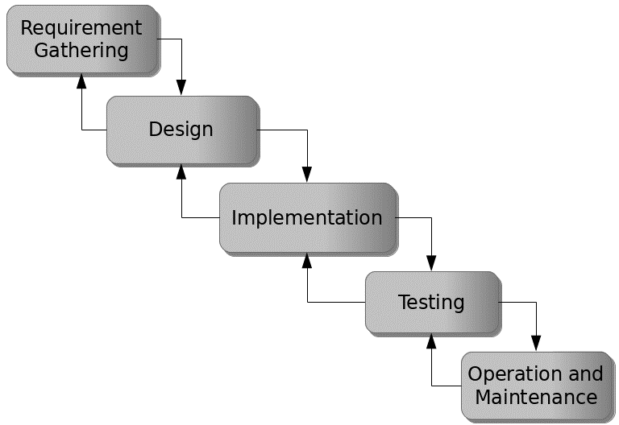

Figure 3.1: Waterfall model

## 3.5 Method of Data Collection

This study will adopt two methods of data collection which are the primary and secondary method.

## 3.6 System Design

Systems design is the process of defining the architecture, modules, interfaces, and data for a system to satisfy specified requirements. Systems design could be seen as the application of systems theory to product development.

## 3.6.1 Algorithm Diagram

**Use Case Diagram**

A use case diagram at its simplest is a representation of a user’s interaction with the system and depicting the specifications of a use case.

Registration

Login

Pay NACOSS Fee

Pay Manual Fee

Admin

Student (Guardian)

Pay departmental Fee

View Receipt

Add user

Print Receipt

Log out

Acknowledge Payment

Figure 3.2: Use case diagram

**3.6.2 System Architecture**

Database MySQL

Apache Server

Departmental Fee Payment System



Figure 3.3: System Architecture

**3.6.3 Database Tables/Queries Structures**

## Table 3.1: Transactions Table

|  |  |  |  |  |
| --- | --- | --- | --- | --- |
| **Field** | **Datatype (length)** | **Null** | **Key** | **Extra** |
| id | int(10) | NO | PRIMARY | auto_increment |
| Student name | varchar(50) | YES |  |  |
| Tracking code | varchar(50) | YES |  |  |
| Payment id | Int(10) | YES | FOREIGN |  |
| Registration Number | varchar(50) |  |  |  |
| Payable Amount | varchar(50) |  |  |  |
| Fees | varchar(50) |  |  |  |
| Payable amount | varchar(50) |  |  |  |
| Payment code | varchar(50) |  |  |  |
| Student id | int(10) |  |  |  |
| Date | timestamp |  |  |  |

#### Table 3.2: Fees Table

|  |  |  |  |  |  |
| --- | --- | --- | --- | --- | --- |
| **Field** | **Type** | **Null** | **Key** | **Default** | **Extra** |
| id | int(10) | NO | PRI |  | auto_increment |
| name | varchar(50) | YES |  |  |  |
| description | varchar(50) | YES |  |  |  |
| Amount | int(10) |  |  |  |  |
| Date | timestamp | YES |  | current_timestamp() |  |

#### Table 3.3: Students Table

|  |  |  |  |
| --- | --- | --- | --- |
| **Field** | **Type** | **Key** | **Extra** |
| id | int(10) | PRI | auto_increment |
| gender | varchar(20) |  |  |
| firstname | varchar(50) |  |  |
| lastname | varchar(50) |  |  |
| othername | varchar(50) |  |  |
| Phone number | varchar(20) |  |  |
| address | text |  |  |
| Registration number | varchar(100) |  |  |
| password | varchar(20) |  |  |
| passport | varchar(255) |  |  |
| Date | timestamp |  |  |

#### Table 3.4: Users

|  |  |  |  |  |  |
| --- | --- | --- | --- | --- | --- |
| **Field** | **Type** | **Null** | **Key** | **Default** | **Extra** |
| id | int(10) | NO | PRI |  | auto_increment |
| username | varchar(50) | YES |  |  |  |
| password | varchar(100) | YES |  |  |  |
| Role | varchar(50) | YES |  |  |  |

**3.6.3 Database Entity Relationship Diagram**

This shows the relationship of the various tables in the database with each other

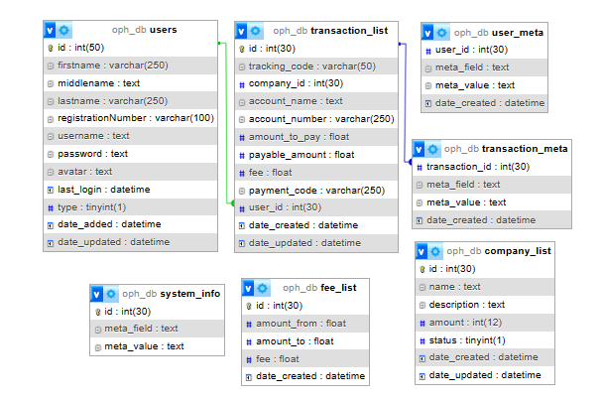

Figure 3.4: Database Entity Relationship Diagram

**3.6.4 The Input and Output Design**

**LOGIN INTERFACE**

Enter Username

Enter Password

#### Don't Have an Account? Sign Up

Login

Figure 3.5: Login interface

First name

Middle name

Last name

Gender

Date of Birth

Phone Number

**SIGN UP FORM**

Address:

Email:

Confirm password

Password:

Passport

**CREATE PROFILE**

Figure 3.6: Sign Up Form

**NEW PAYMENT**

**2,050**

**PayPal**

VISA

**Cancel Account**

**PayPal Credit**

MasterCard

Verve

Amex

Amount to pay: 2,050

Service fee: 50

Figure 3.7: Payment interface

Select payment

Student Name

**Make Payment**

Registration Number

Amount

PAY

Figure 3.8: Make Payment Interface

**TRANSACTIONS INTERFACE**

| **#** | **Date Created** | **Transaction Code** | **Information** | **Paid Amount** | **Action** |
| --- | --- | --- | --- | --- | --- |
| 1 | 2023-08-16 12:34 | KMA-895765255365 | **Student Name:**  AKAMSHU EYUAH  **Registration Number:**  ST/CS/HND/20/002 | 2,550.00 | Action Toggle Dropdown |
| 2 | 2023-08-15 09:42 | PXR-350533781847 | **Student Name:**  KPONKIUS DEV  **Registration Number:**  ST/CS/HND/21/002 | 1,550.00 | Action Toggle Dropdown |
| 3 | 2023-08-15 09:41 | ZYB-373884035733 | **Student Name:**  KPONKIUS DEV  **Registration Number:**  0903840034 | 4,550.00 | Action Toggle Dropdown |

Figure 3.9: Transactions interface

**NACOSS FEE**

**AJAVER JEREMIAH**

**Make Payment**

**ST/CS/ND/21/047**

**1000.00**

PAY

Figure 3.10: Payment confirmation interface

## 3.7 System Requirements Specification

**3.7.1 Hardware Requirements**

The software designed needed the following hardware for an effective operation of the newly designed system.

1. A system running on intel, P(R) duo core with higher processor
2. The-Random Access Memory (RAM) should be at least 3GB.
3. Enhanced keyboard.
4. At least 200GB hard disk.
5. V.G.A or a colored monitor.

**3.7.2 Software Requirements**

The software requirements include:

1. A window 7 or higher version of operating system.
2. XAMP or WAMP for Database
3. PHP

## 3.7.3 Personnel Requirements

Any computer literate who has a technical knowhow of internet surfing can use the system because it is user friendly.

# CHAPTER FOUR

# RESULTS AND DISCUSSION

## 4.1 Introduction

The new system is designed using PHP and MySQL programming language for easy records inserting and updating. This system will help in managing and easily retrieving of information from the system for management purposes. The new system Departmental Fee Payment system for the department of Computer Science is developed for the purpose of Departmental Fees payment in the department of computer Science Federal Polytechnic Mubi.

## 4.2 Results

**4.2.1 Welcome Interface**

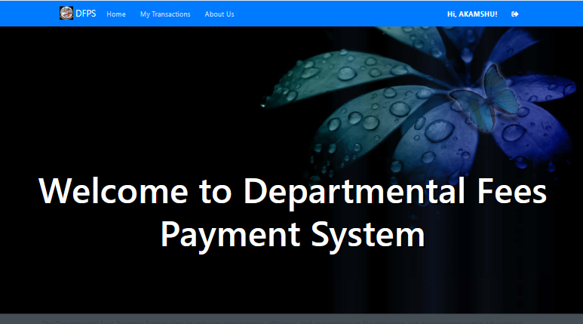

Figure 4.2.1: Welcome Interface

The above figure 4.2.1 shows the welcome page of the Departmental Fees payment system, on the welcome page is the first page that displays on opening the program.

**4.2.2 Login Interface**

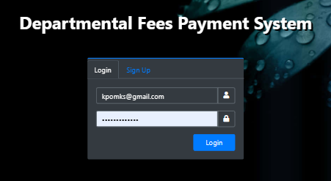

Figure 4.2.2: Login page interface

Figure 4.2.2 above shows the system login page interface. The login interface allows the Students and Administrator to enter his username and password to get access to the system.

**4.2.3 Registration Interface**

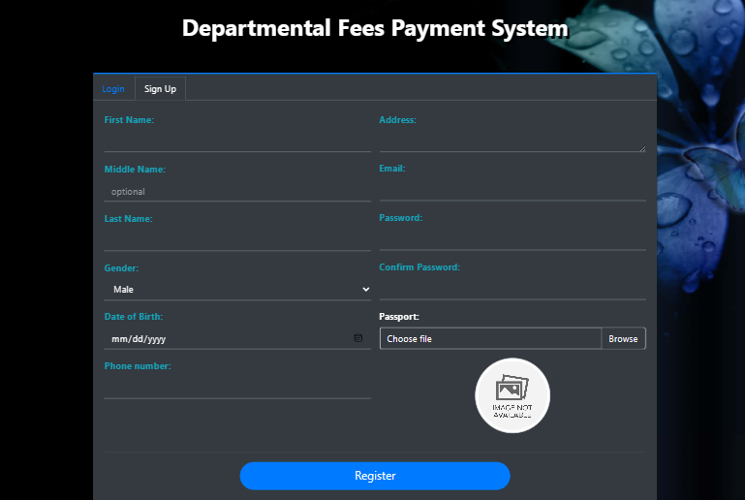

Figure 4.2.3: Registration Interface

Figure 4.2.3 above shows where the student can register to gain access into the system using some basic information like the student first name, lastname, othername, level, matriculation number.

**4.2.4 Make Payment**

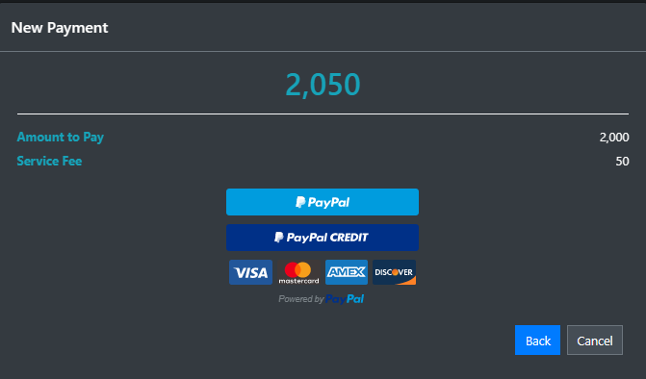

Figure 4.2.4: Make Payment Interface

Figure 4.2.4 is used to make payment online for the departmental fees using the PayPal payment system.

**4.2.5 New Payment Interface**

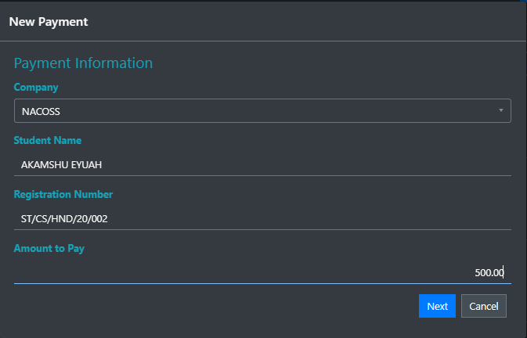

Figure 4.2.5: New Payment Interface

Figure 4.2.5 above is used to select a payment type (departmental, NACOSS or Practical manual fee) before proceeding to the payment gateway.

**4.2.6 Payment Receipt**

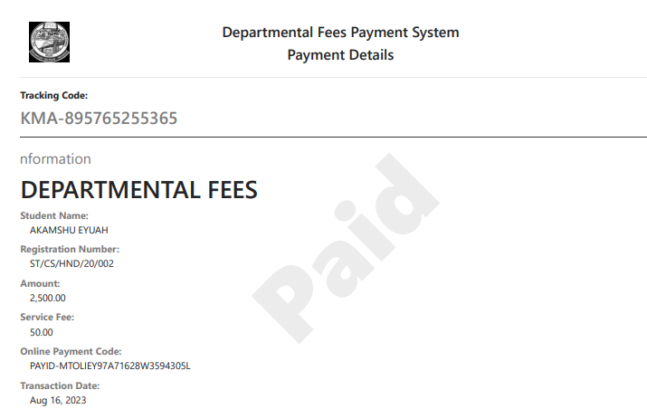

Figure 4.2.6: Payment Receipt

Figure 4.2.6 above is showing a payment receipt after successful payment has been made.

## 4.3 Discussion

Login interface is used by an existing or newly registered student or admin to gain access into the system and access can only be gained when a user enters correct username and password. The purpose of the login is to enable the student or admin have access to the full content of the system.

Registration Interface section is used by the add new student so that he/she can have access to the system and through this the student can get a password and username to enable the student use the system.

Payment section is used by the student to make payment for either the departmental fee, practical manual or the NACOSS fees during registration process for the academic session.

Transactions section provides users with a comprehensive overview of their entire transaction history within the departmental payment system. It serves as a central hub for monitoring financial activities. Key features and benefits include; a chronological list of all past transactions, including payments and refunds, filters and sorting options to organize transactions based on criteria like date, status, or payment type, links to view detailed receipts for each transaction.

The "Make New Payment" section enables users to initiate new fee payments for various departmental services or activities. This section is essential for ensuring that users can conveniently settle their financial obligations. Key features and benefits include; selection of fee categories and specific items, with associated amounts, real-time calculation of the total payable amount based on user selections and Integration with secure online PayPal payment gateway to facilitate electronic payments.

Dashboard is the admin section that is used to display all the available operations that an admin can perform on the system such as adding new lecturer, new student, add new course and add department.

View receipt section allows users (students, parents, or guardians) to view receipts for their previous payments. It offers transparency and helps users keep track of their financial transactions with the educational institution. Key features and benefits include; access to downloadable or printable receipts for each payment made, detailed breakdown of the payment, including fee items, amounts, and dates.

The "Add User" section is typically accessible to administrators or authorized staff members. It allows them to manage user accounts and grant access to the payment system. Key features and benefits include, User registration or creation of accounts for students, parents, guardians, and staff members, User authentication and access control to ensure data security and privacy. Assigning roles and permissions to different user types (e.g., students, parents, administrators).

## 4.4 User manual

The following are the necessary steps to take in order to use the system efficiently and effectively.

1. Load the url of the system <https://localhost/dfps/> the welcome page will be displayed.
2. Click on the **Proceed** button to proceed to the main system.
3. If you created an account, provide your login details by entering your username and password.
4. Depending on the login details provided you will be automatically directed to the dashboard.
5. The various task that you can perform on the portal will be displayed on the sidebar of the dashboard.

# CHAPTER FIVE

# SUMMARY, CONCLUSION AND RECOMMENDATIONS

## 5.1 Summary

The "Design and Implementation of Departmental Fees Payment System" is a comprehensive study focused on creating an efficient and user-friendly platform to manage departmental fee payments in Computer Science Department. The system streamlines the process of fee collection, enhances transparency, and provides users with a convenient online platform to view receipts, make payments, and access transaction history. Throughout this research, we have developed and implemented a robust web-based solution that addresses the challenges associated with manual fee processing, thereby contributing to improved financial management within educational departments.

## 5.2 Conclusion

In conclusion, the design and implementation of the departmental fees payment system mark a significant advancement in the way educational institutions manage and process fee payments. The system's integration of user-friendly interfaces, secure payment gateways, and real-time transaction tracking empowers students, parents, and administrators alike. By automating the fee payment process, the system reduces administrative workload, minimizes errors, and enhances financial accountability. The successful deployment of this system demonstrates its potential to revolutionize fee management practices and significantly contribute to the overall efficiency of educational institutions.

## 5.3 Recommendations

The researcher puts forward the following recommendations:

1. It is recommended that the system be implemented in the Department of computer science for easy departmental fees payment.
2. The researcher also recommends that the system be put to effective use in order to derive the necessary efficiency of the system.
3. It is also, recommended to conduct periodic training sessions to ensure that users, especially parents and guardians, are fully aware of the system's features and benefits.

## 5.4 Contribution to Knowledge

The new system was designed in a structured and robust way employing responsive design to it to ensure usability and efficiency. The project research will serve as a reference point for other research work and contribute immensely to knowledge for those conducting a research on similar topic.

## 5.5 Area for further work

The research work is limited to a single payment gateway (PayPal) and web-based system. Therefore, the researcher suggests that further studies be conducted to include the development of an application (android or IOS) and other payment gateways such as Remita, Paystack etc. to ease the utilization of the system.

# REFERENCES

Al-khouri, M. & Gehrke, M. (2020). An Integrated Framework for E-Records Management System (ERMS) Development: A Study on Bangladesh Government Sector. *International Journal of Electronic Government Research*, 16(3), 19-38.

Anderson, L., & Patel, S. (2022). Ensuring Data Security in Payment Systems for Educational Institutions. *International Journal of Cybersecurity*, 18(1), 45-60.

Brown, K., & Martinez, A. (2022). Digitalizing Student Fee Management: Challenges and Opportunities. *Journal of Educational Administration,* 46(1), 89-105.

Brown, K., & Smith, J. (2022). The Impact of Payment Systems on Error Reduction in Educational Institutions. *International Journal of Educational Finance,* 20(1), 56-70.

Chen, J. & Chen, K. (2021). Cloud-Based Property Management System with Mobile Integration for Small and Medium-Sized Landlords. *Journal of Systems and Information Technology*, 23(3), 486-503.

Delen, A. (2021). Design and Development of Mobile Applications for Property Management. *International Journal of Information Systems and Project Management,* 9(2), 5-19.

Elmasri, R., & Navathe, S. B. (2019). *Fundamentals of Database Systems.* Pearson, New York.

Huang, M. (2021). The Adoption of Property Management Systems in the Real Estate Sector. *Journal of Business and Management*, 23(2), 71-92.

Ionita, H. & Gorges, O. (2016). An Artificial Intelligence Platform for Property Management: *A Conceptual Model. Computers in Industry*, 125, 103-379.

Johnson, R., & Martinez, A. (2021). The Importance of Financial Transparency in Educational Institutions. *Journal of Education Finance and Policy,* 25(2), 89-104.

Khumalo, N. (2020). Evaluation of Records Management Systems in Public Universities in Kenya. *International Journal of Information Systems and Project Management,* 8(3), 43-62.

Lee, S. & Koo, J. (2020). Web-based Rental Property Management System for Efficient and Effective Property Management. *Journal of Engineering Technology*, 18(1), 221-229.

Li, K., Letchkov, N., Koychev, I., & Ivanov, B. (2020). Cloud-Based Property Management Systems. *In Proceedings of the International Conference on Advances in Business, Management and Law*, 7(1), 169-177.

Ming, I., & Hashim, L. (2020). The Role of Management Information Systems in Data Analytics: A Strategic Perspective on Global Business Environments. *Information Systems Frontiers,* 22(4), 909-924.

Motahari-Nezhad, H. R., Stephenson, B., Shahbazian, M., & Foster, H. (2021). Database Management Systems. *In Handbook on Securing Cyber-Physical Critical Infrastructure* (pp. 195-217). Springer.

Patel, S., & Johnson, M. (2023). Student Perspectives on Payment Systems in Higher Education. *International Journal of Educational Technology*, 15(1), 34-48.

Ramakrishnan, R., & Gehrke, J. (2020). *Database Management Systems*. McGraw-Hill.

Rizvi, S., Khan, M. A., Bhatti, R. A., & Ziauddin, Z. (2021). A Comparative Study of Database Management Systems. *Journal of Information Systems and Technology Management*, 18, 202-1134.

Smith, J. (2021). Digital Transformation in Higher Education: Advancements and Challenges. *International Journal of Educational Technology,* 12(4), 65-79.

Sutano, U., Sutano, Y., He, X., & Fan, W. (2020). Mobile Property Management Systems: A Study of Design and Implementation. *Information Systems Frontiers*, 1-14.

Turner, R., & Gonzalez, E. (2023). Improving Financial Management in Universities with Payment Systems. *Journal of Higher Education Management,* 16(2), 78-92.

Wang, S., Liu, M., & Lee, Q. (2021). A Framework for Smart Rental Property Management. *IEEE Access*, 8, 134127-134139.

Wu, L., & Brown, K. (2022). The Role of Automation in Educational Financial Management. *Journal of Information Technology in Education,* 15(3), 120-135.

Wu, L., & Lee, C. (2023). Security Considerations in Designing University Payment Systems. *Journal of Information Security,* 35(2), 213-228.

Zhang, H., & Chen, Q. (2022). Adoption of E-payment Systems in Higher Education: A Comparative Study*. International Journal of Educational Technology*, 14(3), 57-72.